A00046191 Samuel Attila Zemes
CLoud Computing Y4
03-11-2025
Quality of Life WORLDWIDE
Word Count : 3881 words

Contents
Introduction 2
Objective for the report: 2
Body of work 2
Have you seen similar visualisations before? 2
Dataset 2
Seven Stages of Data Visualisation Approach 3
Acquire 3
Parse 4
Filter 4
Mine 7
Represent 9
Refine 10
Interactivity 10
Dashboard Design 11
Conclusion 12
References 13

Introduction
This visualisation aims to compare the quality of life worldwide, like in Afghanistan and Europe, using specific indicators, helping users understand the differences between stable and unstable countries. The metrics enable us to distinguish between war-torn nations, such as Afghanistan and Somalia, and more stable European countries, like Estonia or Finland. For the perspective and visual analyses, we use three major visualisations that are grouped into an interactive dashboard, allowing users to select multiple countries and receive a visual comparison across multiple EU countries.
We are using three visualisations in the Dashboard. These are :
- Emotional Well-Being per Country
- Health–Support Difference Index per Country
- Population Awareness about Corruption in Government
To demonstrate the purpose of the Dashboard visualisation, we are using the seven-stage approach that will clearly outline how we achieve the visualisation result.

Objective for the report:
- Research if there was an attempt to create a similar visualisation
- Create a visualisation using the seven stages of Data Visualisation
- Define Calculate fields and why we are using them
- Describe the dashboard design and features

Body of work

Have you seen similar visualisations before?
The short answer is yes, but with more statistical detail. These visualisations aimed to find out the life expectancy of people, log per GDP capita, and happiness rate. Still, none of them attempted to compare the quality of life using their own metrics in war-torn countries with stable ones, such as within the EU zone [excluding Ukraine, they been at war since 2023].
The created dashboard employs an analytical approach, incorporating storytelling, to highlight the contrast in quality of life using actual metrics and graphs. In contrast, others attempt to rank countries from best to worst.

Dataset
The dashboard is built on two datasets from Kaggle, specifically the World Happiness Report 2024, which was created by the site's user, Jaina. The dataset focuses on social support, freedom of choice, and the positive and negative effects, among other aspects, across 140 countries. We are merging the values from the datasets to effectively display our dashboard visualisation and enable the user to see the results.

Seven Stages of Data Visualisation Approach
The Seven Stages of Data Visualisation is a methodology that outlines a process for transforming raw data from datasets into a visual representation. As the name suggests, the methodology consists of seven stages.
The report aims to demonstrate how our approach to creating the dashboard visual aligns with the practices of this methodology.

Acquire
In this stage, we will explain how we acquire the data set used in the Dashboard.
We are gathering the data set, which will serve as the core for our dashboard. There are many dataset sites, but most high-quality, reliable datasets are found on Kaggle. Since the datasets that Tableau supports are varied, but the most supported platforms are JSON and CSV formats, we use CSV for simplicity. This format allows for manual editing in emergencies, has a more transparent structure, and does not require programming skills to edit.
In Kaggle, the first step is to set up the filter to set what type of dataset. Settings are :
- Clean Data
  - The reason this filter is applied is that it allows us to access the most suitable dataset, saving us time in Tableau Prep by reducing the need to re-align all errors in the dataset.
- CSV Format of Data Set
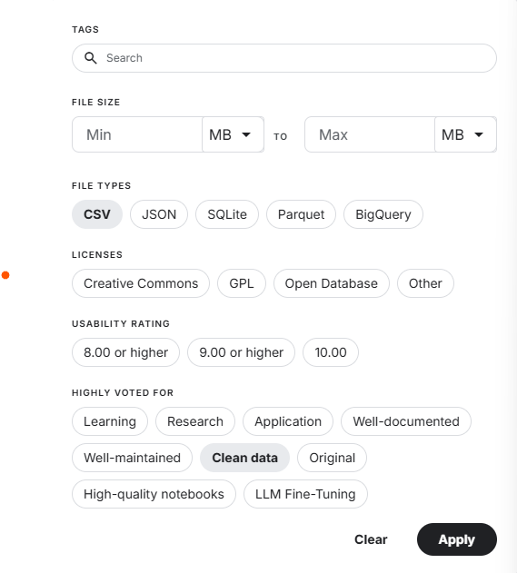
Figure 1:This Figure showcases the Filter that is on Kaggle.

With this filter, we access the World Happiness Report 2024 CSV used in our dashboard. As Figure 2 shows, we click "Download in zip format," which downloads our CSV file and thus completes the first stage of the methodology.
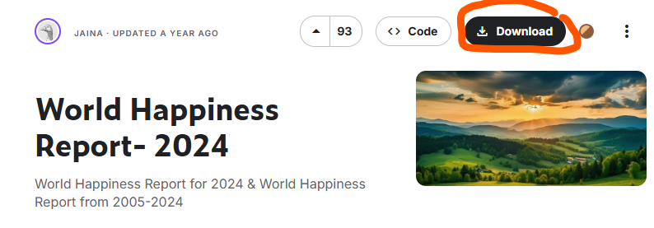
Figure 2: This Figure showcases the download of the CSV File.

Parse
Upon inspecting the CSV files, there were data gaps within the file, most of which were located in the updated version of the CSV [World Happiness Report updated CSV]. However, the dataset was structured correctly. If it was not set correctly and string values were located in integer columns, the data would either be removed or checked for errors in the order of rows or columns, and then manually moved. But since this is almost clean data, this process was avoided.

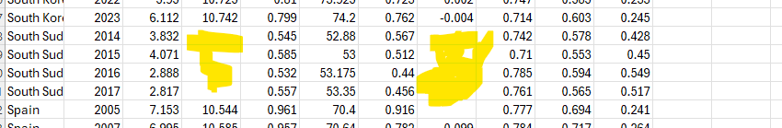
Figure 3: This figure shows Data Gaps in the CSV

Filter
In this section, we are using Tableau Prep to filter and adjust the data. We took two CSV files and proceeded to clean them first. The reason is that before doing a Join or Union, we wanted to ensure that no Null Values [or empty fields as in Figure 3] were passed to the Join process and that the data was precise.
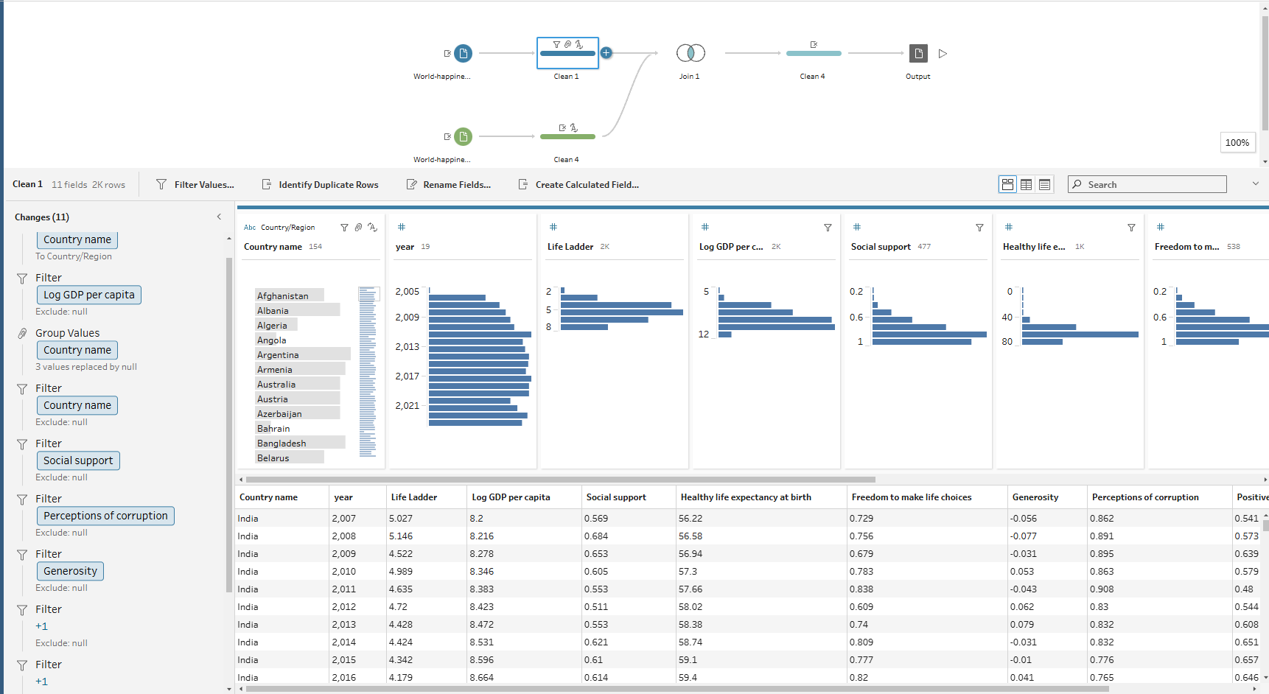
Figure 4: This Figure showcases the initial Cleaning and Filtering of Null Data
As shown in Figure 4, each field in the CSV had the data gaps illustrated in Figure 3. These are classified as Null Values or Empty Values. The decision was made to exclude these values.
Reasons:
- The year and other bound values in the empty cells could disrupt the calculations. Hence, exclusion means deleting entire rows of data that are empty, regardless of whether other data exists.
- This ensures precise calculations. Zero in maths is still a value, regardless of human interpretation.
The same filtration was applied to the other CSV as well. Once the data is cleaned, we can join them. To perform the join in Tableau Prep, we need two similar values from both tables, which in this case are Countries.
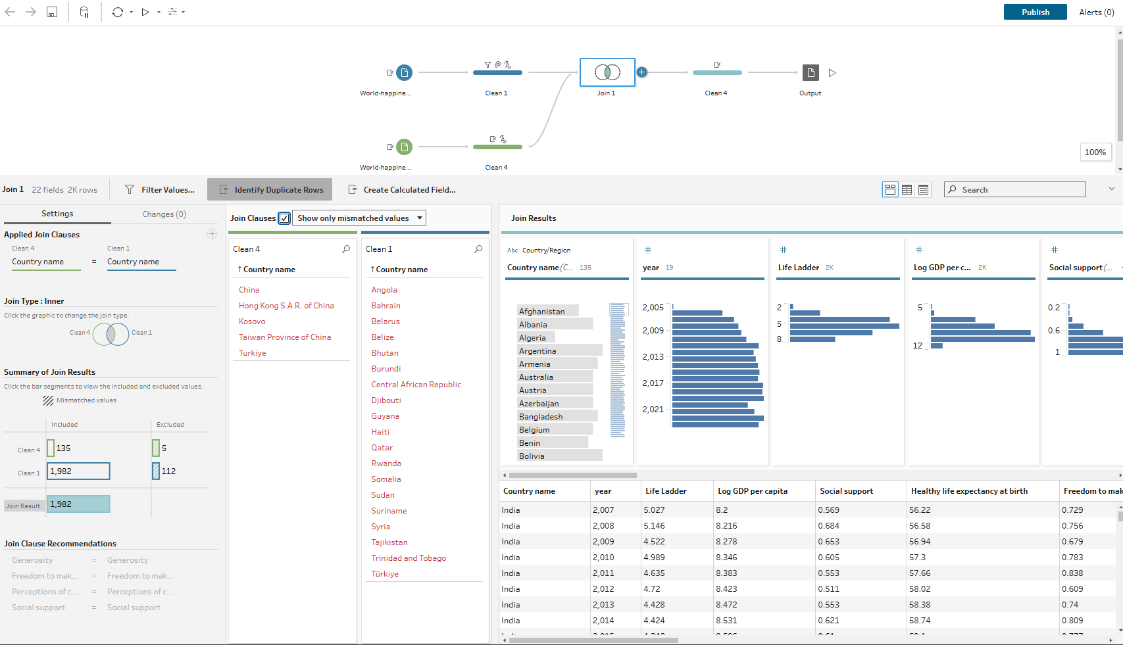
Figure 5: This Figure showcases the Inner join with two datasets
As the picture illustrates, we are using the inner join method to combine the two datasets into a single one. However, this approach has its own consequences. There will be scenarios where not all data matches, and in our case, we are missing data from both tables. Now we have two options. :
- We fix the problem in each CSV by creating a country with all the data in rows and columns, but there is also the fact that, since we don’t have all the data, we might create our own, which is not ideal.
- Or we exclude the countries and use the data that we have. Excluding from the inner Join process within Tableau Prep is done automatically. Hence, this is why we chose this option, since there are only a few missing countries
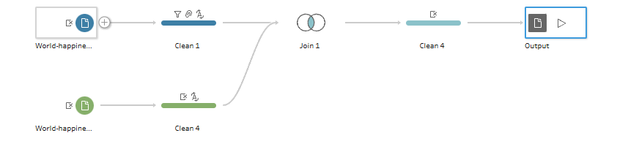
Figure 6: This Figure shows the Setup in Tableau Prep
And as the final step, we exclude redundant data in the Join. In my case, we have two datasets, one with 160 entries and the other with 2,000 entries, each representing Log GDP per capita. We use the larger one, as it enables us to perform more accurate calculations.
Lastly, we have the output version section. Here, we can specify where the output of the filtered CSV file will be located and in what format. We use the CSV option because it is the most versatile of the three available options. The output will be a clean CSV sheet with no data gaps, like in Figure 3, and can be forwarded.
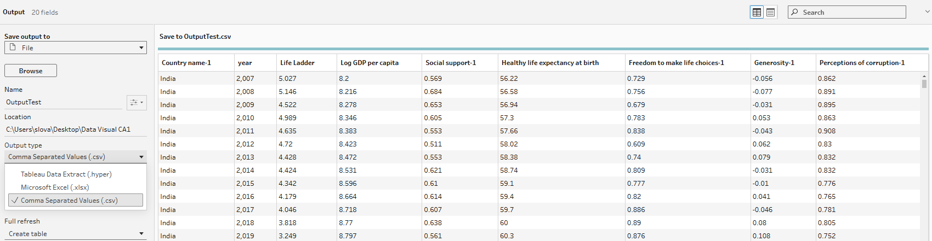
Figure 7: This Image Showcases the final output in Tableau Prep
Note: The author initially made a mistake when cleaning and preparing the data. We accidentally used two copies of the same CSV file, which were joined into one, resulting in a Visualisation dependency. The CSV file used twice was the World Happiness Report Updated 2024, now renamed to TEST.csv. Once the mistake was discovered, it was too late to fix it since the visualisation had already depended on it. However, the author managed to join the tables in Tableau Desktop, and we can now use functions from both CSVs.

Mine
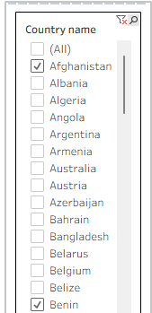
In this stage, we are creating special calculation fields to help us examine specific aspects of our dataset. Since our dataset focuses on happiness and global well-being, we need to clearly define how we interpret these concepts to analyse the data effectively.
We are using two significant coefficients across the visualisations:
- Country
- Year
Why are we using these? They allow us to filter data across multiple visualisations effectively. This centralised filtration enables us to examine trends within each country over time and observe how the data develops year by year.
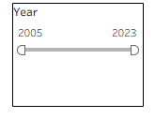
Figure 8 : This figures showcases the filtration in the dashboard using two data fields across multiple visualisation

How does the filtration work in Tableau?
Filter settings in Tableau worksheets allow us to apply data filtering across all sheets or to specific ones. If we choose to apply the filter across all worksheets, it becomes universal, meaning that any changes made to the year data filter will be reflected in all sheets within Tableau. Conversely, if we select filters for specific visualisations, the settings will only apply to the chosen worksheets. The result is that we apply the filtration based on the needs of our visualisation and what we want to display to the user.
  - Health–Support Difference Index per Country
Our initial focus will be on health, specifically life expectancy at birth and social support. It is well known that Western countries excel in this area, where life expectancy is significantly higher compared to countries in conflict, where life expectancy often falls well below the minimum standards set by the EU.
The question we need to address is: how can we prove this disparity? The answer lies in our method: we will subtract the social support coefficient from the data for life expectancy at birth. Both values will then be averaged to yield our results.
Use Example:
AGG(AVG([Healthy life expectancy at birth])-AVG([Social support]))
[Plus the two major coefficients used across the worksheets ]
Explanation:
We are calculating an aggregated value using two previously mentioned metrics to determine the average age in the selected countries. The Healthy Life Expectancy at Birth is an average value that considers the maximum lifespan. The author of the dataset calculated an average value for each country based on data collected over the years.
Regarding social support, this is represented by a coefficient that evaluates the availability of social services and the willingness of family members to assist individuals in times of need. It is based on a binary response; when asked whether people will help, responses are either "Yes" or "No." From this, we developed a coefficient in the format of 0.xxx and subtracted it from the Healthy Life Expectancy at Birth.
Result:
We can track the Health–Support Difference Index per country, which helps define the support index in a given country. This, in turn, enables us to monitor overall life expectancy, taking into account social services.
  - Population Awareness about Corruption in Government
Population awareness about corruption can be represented by a visual line coefficient, which illustrates the level of awareness regarding corruption in a given country. This visualisation is included in the dashboard to show the percentage of corruption within the country. Generally, a lower percentage of corruption indicates a higher quality of social services provided. Conversely, if the corruption percentage is high, it suggests that social services are inadequate. As a result, the population's awareness of corruption tends to increase because financial resources are not being effectively utilised in the social sector.
Approach in this sheet :
AVG([Perceptions of corruption])
[Plus the two major coefficients used across the worksheets ]
Result :
This displays the level of corruption awareness among the population of the selected country. We are showcasing the data over time using year-based filtering options. This reflects public trust in the country's government and its institutions. The highest percentage of awareness regarding corruption within the population indicates a significant mistrust in the selected country's institutions among its citizens.
  - Special Mine settings applied in marks for Corruption
In this analysis, we utilise a specially calculated field to illustrate corruption levels in each country. In Tableau, we created these calculated fields to display the maximum and minimum values for each country. This is achieved with the following command:
IF [Perceptions of corruption] = { FIXED [Country name1] : MIN([Perceptions of corruption]) }
THEN [Perceptions of corruption]
END (Betzendahl, 2019)
The IF statements check whether the field exists; if true, it displays the data in the specified column; if not, it ignores the rest of the statement. The data in the display column must correspond to the fixed country name. This approach is used because the corruption perception data will be associated directly with that particular country. Without this method, we would only display the single highest and lowest values across the entire dataset, ignoring other relevant data.
This approach allows us to see the minimum and maximum values specific to each country's dataset. It is essential to utilise the MIN and MAX functions to ensure the calculation statement accurately identifies the minimum and maximum values within the dataset.
If all these conditions are met, we then use the "THEN" statement to display the corresponding actual data in the designated field in Tableau. The "END" keyword signifies the conclusion of the calculation statement.
  - Emotional Well-Being per Country
In the field of Emotional Well-Being, we focus on two key dimensions: Positive Affect and Negative Affect. To determine the overall level of well-being in each country, we will use an aggregated statement that combines these dimensions to produce a net result.
Statement :
SUM([Positive affect])-SUM([Negative affect])
[Plus the two major coefficients used across the worksheets ]
Result :
This worksheet collects data on emotional well-being over time. By analysing this data for each country, we can determine whether the country is emotionally happy or facing issues such as depression or sudden environmental changes that negatively impact its population.

Represent
In this section, we will discuss the selection of appropriate charts for our dashboard and their significance. Our dashboard features four different charts:
- Column Chart: The primary purpose of this column chart is to display the Health-Support Difference Index for each country. It enables users to compare the differences between the indices of various countries visually. It gives an overview of the average index for each country. The chart presents countries along the columns, with an aggregated calculation field in the rows, visually creating a bar chart. The results shown in this chart represent life expectancy, as measured by the aggregated average age column.
- Area Chart: This chart represents Emotional Well-Being, categorised by country and year, with an aggregated calculation field that generates the net result of emotional well-being. The area chart is set in percentage format, with separate axes for positive and negative percentages. A value on the positive axis indicates that emotional well-being in the given country is favourable. In contrast, a negative value suggests ongoing issues in that country.
- Line Chart: The line chart in our visualisation represents the trajectory of the percentage corruption index, allowing users to understand the current awareness of corruption in each country. Users can observe the minimum and maximum values of the chart through a specialised calculation field that facilitates easier identification of these values. The goal of this chart is to provide a visual comparison of corruption awareness over time in the selected country.
- Metrics: Lastly, we display selected metrics above the charts. This placement highlights the most critical data that we consider essential for users, allowing them to view significant statistics from the selected countries at a glance.

Refine
Refine is the 6 stage in the data visualisation. I want to discuss the implementation of this stage in the dashboard. We use :
- Colours :
  - In our column chart, we use a gradient shade of blue to illustrate the differences between the various countries. This gradient colour scheme makes it easy for users to identify which country is the most supportive based on the age index. The gradient blue legend, located in the top right corner of the dashboard, indicates that a darker shade corresponds to a country with a better health index.
  - In the area chart, we also use colour differentiation to represent each country's value. When a new country is added to the area chart, Tableau automatically assigns a colour to it. Users can reference this colour in the legend, which is positioned on the right side, above the filters. This setup enables easy cross-referencing between the colour and the country, allowing users to identify the data effectively.
  - Colour consistency in each given chart is a must to ensure the clarity of the visualisation and straightforward storytelling of the data in the given visualisation
- Lines
  - Average Line: In the column chart, we use the average line to display the average age index based on the selected country. This allows users to identify the average age index in that given chart.
  - Trend Line: This line is used in the corruption visualisation. It is designed to predict future trends based on the data we have. Thus, please provide us with an estimate of whether the presence of corruption in the population will lead to a decrease in public awareness or an increase, potentially creating future issues. This allows us to predict potential strikes or other adverse actions by the people of the given countries.
- Hierarchy and formatting of the Dashboard
  - The hierarchy and formatting of the dashboard are crucial for presenting clear data visualisation. Adequate padding throughout the entire dashboard is necessary to ensure that the data does not overlap. This will create a consistent appearance, with each visualisation having clearly defined borders, ultimately leading to a well-structured dashboard.

Interactivity
As mentioned in my section, we have filters that allow users to interact with the datasets and observe developments over the years. This feature enables users to create their own analyses based on the data collected in the charts and metrics. For example, a user can select specific countries, such as Afghanistan, Estonia, and Germany, and choose a time period of interest, such as 2005-2015. The results will display the data for that time span, allowing users to reference the information from the dashboard and witness the evolution of the data.
The primary goal of the interactivity section is to facilitate storytelling by enabling the filter function, allowing users to visualise the evolution of the data and create meaningful narratives directly from the dashboard.

Dashboard Desing
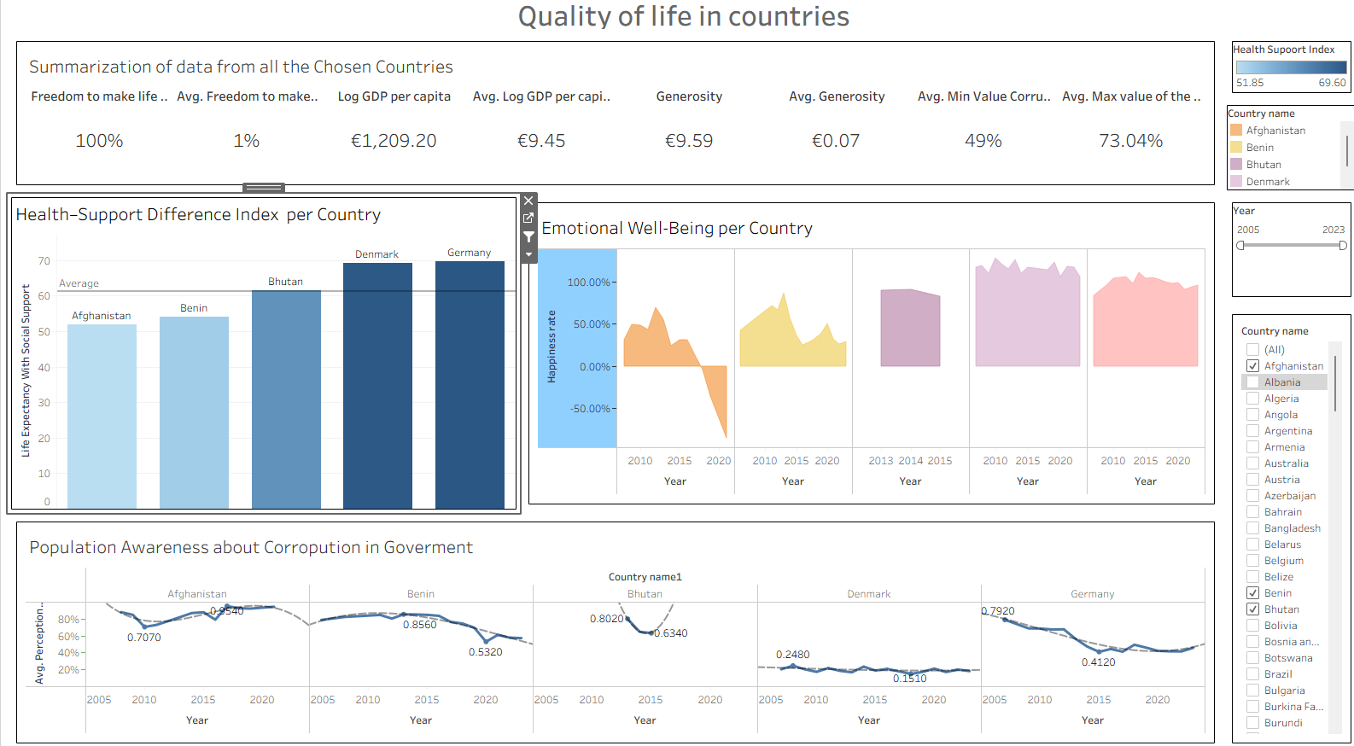
Figure 9: This image shows the final version of the Dashboard
This dashboard comprises four visualisations and filters, designed based on strategies and insights from previously well-designed dashboards. We have incorporated these effective strategies into our design:
- At the top of the dashboard, key metrics are displayed, representing the most essential data that users should focus on. Currently, these metrics summarise information for all selected countries.
- On the left side, a column chart is presented, while an area chart appears on the right side. This arrangement provides users with a unique overview to observe the correlation between the Health Index and emotional happiness, highlighting how these factors influence one another. The main goal is to help users assess the Quality of Life based on these metrics and visually understand the situation in each country.
- At the bottom, a line graph illustrates the population's awareness of corruption in each respective country. This graph could address questions such as why Afghanistan has a Health Index of 50 while experiencing unhappiness. One contributing factor is the population's awareness of corruption in the country, which leads to a lack of trust in the local government. The Corruption Line chart aims to provide insights into the question of why the quality of life is on such low or high standards.

- Filters in various dashboards are typically located on the right side of the screen. This layout is designed with the majority of users in mind, as a significant portion of the population is right-handed. Placing the filters on the right allows for a more natural interaction with the interface. The filters based on the country and year provide several benefits:
  - Engage users through storytelling
  - Allow for the viewing of clean data from the selected country
  - Enable analysis of data trends over time
  - Encourage inquiries about the reasons behind specific trends in the given country
To ensure a clear structure in dashboard design, we implement the following practices:
- Clarity
  - Clear titles and visualisation deployment on the dashboard should provide the answer for the data that we want to provide to the user
- Logical Layout
  - With limited dashboard space, we need a clear deployment of the visualisation into the dashboard and ensure that the visualisations do not overlap
- Interactivity
  - Ensure that the user can interact with the dashboard via Filters and that the data changes when the user uses different filters that are available to them
- Readability
  - Ensure that visualisations are readable and colours used are not overlapping
This structured approach in the dashboard enables users to identify the situation in each country easily. We ensure that we deploy a well-designed dashboard that adheres to established best practices. It should provoke questions and provide answers regarding the reasons behind the data, ultimately creating a storytelling dashboard.

Conclusion
In this document, we provide comprehensive documentation on dashboard deployment using Tableau services. We follow the Seven Stages of Data Visualisation and outline our approach to creating dashboards within this structured framework. Our complete documentation details the seven-stage methodology, which includes downloading data, cleansing it, joining datasets, creating visualisations, calculating fields, and implementing visuals on the dashboard. As a result, we have developed a dashboard that presents various stories.
One particularly noteworthy story that emerges from the dashboard is related to Afghanistan. The data reveals a significant decrease in overall happiness in 2021, coinciding with the NATO withdrawal from Afghanistan and the subsequent attempts of many people to escape the Taliban takeover and persecution. This decline is also reflected in the log per capita income; the Afghan population became poorer compared to 2013-14, when the log per capita was approximately €30, but dropped to €15 in 2021. One reason for the halving of per capita income is that between 2018 and 2019, the U.S. was gradually preparing Afghanistan to become independent of U.S. assistance; however, the data show that this effort ultimately failed by 2021.

Possible future visualisations from this story could include:

- Life during U.S. occupancy versus after
- Decrease in quality of life
- The number of people who can afford food
- Rising poverty rates
In conclusion, the overall outlook for Afghanistan is expected to be largely negative, with anticipated gaps in data as the Taliban will likely regulate information coming out of the country.
Another essential aspect to consider is the disparity in quality of life between war-torn nations and Western countries. In Western nations, social services are more developed, resulting in a higher quality of life. For instance, the average life expectancy in Afghanistan is approximately 50 years, whereas in Germany, it is around 80 years. Additionally, there is a significant economic disparity in GDP per capita between Afghanistan and Germany.
When examining economic trends in Europe, we observe the challenges presented by China, which operates on a massive scale in production. Analysing the latest data can help us forecast future trends. Meanwhile, Afghanistan is facing an economic catastrophe, and we can develop models to predict the severity of this disaster. The results could be represented using line charts or area charts to illustrate this comparison clearly.
Furthermore, we should explore how changes in quality standards could impact Germany, particularly in the event of an economic crisis. We can then compare this scenario to Afghanistan or other European countries to determine whether Germany will continue to be the economic anchor for the EU.

References
Analitics, P. (2025). ashboard Part 4 - How to Add a Quick Filter to a Dashboard - Tableau in Two Minutes. Retrieved from Youtube : https://www.youtube.com/watch?v=51cVBCwoqbg&t=2s
Betzendahl, L. (2019, September 11). Using LODs to Compare Max/Min Year Values. Retrieved from Viz Zen Data: https://vizzendata.com/2019/09/11/using-lods-to-compare-max-min-year-values/?utm_source=chatgpt.com

